**REGISTRATION FORM**

School or Organization:



Contact: Email address:

 

Location:



Phone: Ext. Fax:

Preferred method of payment:

 

Preferred method of contact:   
 

Proposed Dates: 1st choice  2nd choice

|  |  |  |  |
| --- | --- | --- | --- |
| Time **(One hour intervals)** | Grade | **Number of Students** | Teacher |
|  |  |  |  |
|  |  |  |  |
|  |  |  |  |
|  |  |  |  |
|  |  |  |  |

Additional Comments or Special Requests: 

*Please allow at least 2 weeks for cancellations. Contact us if you have any questions or changes in the number of students that will be in attendance.*

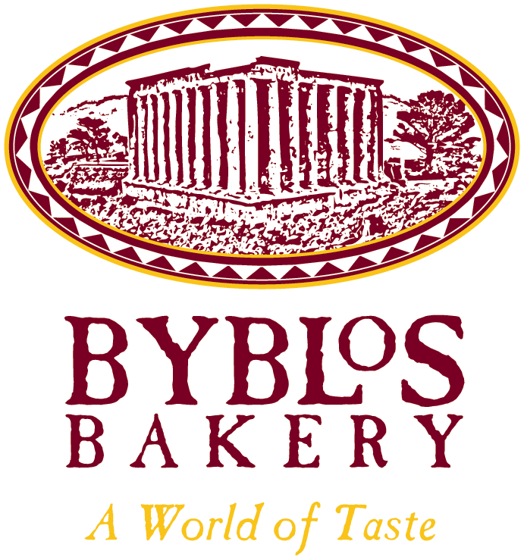Jamie Gervais

Byblos Bakery  
2479 – 23rd St. NE

Calgary, AB T2E 8J8

Head Office: 403-250-3711

Web: <http://byblosbakery.com>

B.Sc. in Nutrition and Food Science

Nutrition Educator

Email: [pitasake@byblosbakery.com](mailto:pitasake@byblosbakery.com)

Web: <http://foodimpact.ca>

Cell: 587-435-7026